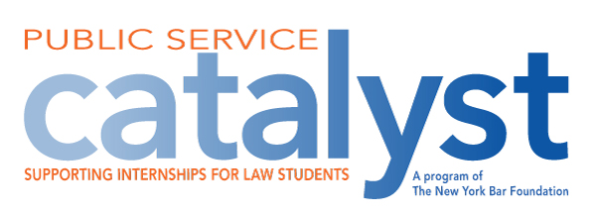

CATALYST PUBLIC SERVICE FELLOWSHIP PROGRAM
SUMMER 2024 APPLICATION
Purpose:
The Catalyst Public Service Fellowship Program was created to encourage and enable first year law students who would not otherwise be able to do so, gain practical legal experience in the public sector. The selected fellows will receive stipends for otherwise uncompensated summer internships with public service employers.

Selection Process:
Catalyst Public Service Fellows are selected by each law school. This year, each law school will be able to select four students to be honored as Catalyst Public Service Fellows, for a total of 60 Fellows from the 15 law schools in New York. In making its selections, each law school will consider the applicants’ financial need and their interest in potentially pursuing public service careers. Preference will be given to first-year students.

Stipend:
The total stipend is expected to be $5,000 for each Fellow for the summer of 2024, $2,500 from Catalyst and $2,500 from the law school. The New York Bar Foundation will provide its portion of the stipend to the law school, which will distribute the full amount of the stipend to each Fellow in cash or appropriate financial credit.

Eligibility:
- All currently enrolled day and evening law students in good standing may apply for a stipend.
Students must obtain an unpaid summer internship with a public service employer. For purposes of the Program, a public sector employer means a New York State prosecutor, a public or not-for-profit agency which provides criminal defense or civil legal services for the indigent and/or representation in juvenile justice or child protective proceedings in New York State courts and the New York State Unified Court System.

- Students are not required to have secured an internship at the time of application and are encouraged to work with their career counselors on their summer internship search. However, if the selected Fellow accepts a position other than an unpaid public service internship, the Fellow will forego the stipend and the law school may make an alternate selection.
- Each Fellow must commit to serving a minimum of 10 weeks, at 35 hours per week, or the substantial equivalent thereof, in an otherwise unpaid eligible public service internship.
- The Fellow may not receive law school credit or monetary compensation from the employer or any other funding source for his or her internship.
Application Requirements (Submit by Monday, March 27, 2024):
- Completed application form
- Resume
- Unofficial law school transcript
- Letter or email from employer confirming employment and number of weeks and hours applicant will be employed. Employer confirmations can be sent or emailed directly to the career services representative. If selected Fellow has not secured a placement at the time of application, this confirmation must be submitted by May 31, 2024.

The fellowship will be awarded in compliance with all applicable laws including those related to non-discrimination on the basis of sex, race, age, creed, color, national or ethnic origin, marital status, sexual orientation, and handicap.

Application Form

Please provide the following information:

Name:

Mailing Address:

Phone/Email:

If position obtained at time of application:
Name of Summer Employer:
For purposes of the Program, a public sector employer means a New York State prosecutor, a public or not-for-profit agency which provides criminal defense or civil legal services for the indigent and/or representation in juvenile justice or child protective proceedings in New York State courts and the New York State Unified Court System.

Name, Title, Address, Email and Phone Number for Employer Contact:

Number of Weeks of Internship/Number of Hours per week:

Please answer the following questions on a separate sheet (not longer than two pages):
How will obtaining the Catalyst Public Service Fellowship will enable you accept an otherwise unpaid public service legal summer internship?
Why do you want to potentially pursue a public service career?

Applicant’s Signature
Date:

